Sum of Subarray Ranges
Problem Statement: Given an integer array nums, determine the range of a subarray, defined as the difference between the largest and smallest elements within the subarray. Calculate and return the sum of all subarray ranges of nums.
A subarray is defined as a contiguous, non-empty sequence of elements within the array.
Examples
Example 1:
Input: nums = [1, 2, 3]
Output: 4
Explanation: The 6 subarrays of nums are the following:
[1], range = largest - smallest = 1 - 1 = 0
[2], range = 2 - 2 = 0
[3], range = 3 - 3 = 0
[1,2], range = 2 - 1 = 1
[2,3], range = 3 - 2 = 1
[1,2,3], range = 3 - 1 = 2
So the sum of all ranges is 0 + 0 + 0 + 1 + 1 + 2 = 4.
Algorithm
- Find the index of the next smaller element to the right for each element using NSE logic
- Find the index of the previous smaller or equal element to the left using PSEE logic
- Find the index of the next greater element to the right for each element using NGE logic
- Find the index of the previous greater or equal element to the left using PGEE logic
- Use NSE and PSEE to calculate the total contribution of each element as the minimum in subarrays
- Use NGE and PGEE to calculate the total contribution of each element as the maximum in subarrays
- Subtract the total of subarray minimums from the total of subarray maximums
- Return the result as the sum of ranges of all subarrays

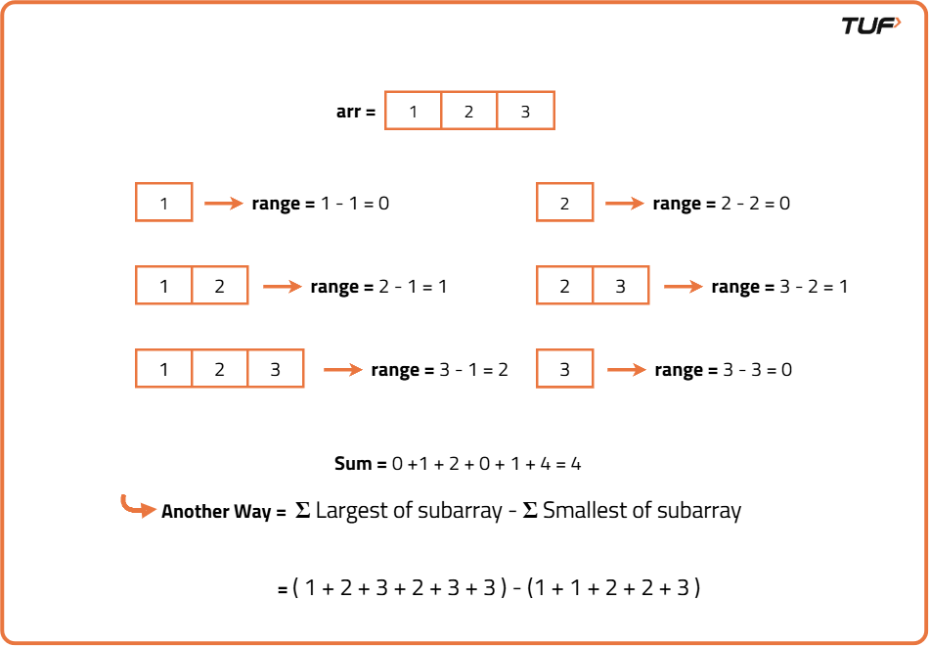

class Solution {

// Function to find indices of Next Smaller Elements
private int[] findNSE(int[] arr) {
int n = arr.length;
int[] ans = new int[n];
Stack<Integer> st = new Stack<>();
for (int i = n - 1; i >= 0; i--) {
while (!st.isEmpty() && arr[st.peek()] >= arr[i]) {
st.pop();
}
ans[i] = !st.isEmpty() ? st.peek() : n;
st.push(i);
}
return ans;
}

// Function to find indices of Next Greater Elements
private int[] findNGE(int[] arr) {
int n = arr.length;
int[] ans = new int[n];
Stack<Integer> st = new Stack<>();
for (int i = n - 1; i >= 0; i--) {
while (!st.isEmpty() && arr[st.peek()] <= arr[i]) {
st.pop();
}
ans[i] = !st.isEmpty() ? st.peek() : n;
st.push(i);
}
return ans;
}

// Function to find indices of Previous Smaller or Equal Elements
private int[] findPSEE(int[] arr) {
int n = arr.length;
int[] ans = new int[n];
Stack<Integer> st = new Stack<>();
for (int i = 0; i < n; i++) {
while (!st.isEmpty() && arr[st.peek()] > arr[i]) {
st.pop();
}
ans[i] = !st.isEmpty() ? st.peek() : -1;
st.push(i);
}
return ans;
}

// Function to find indices of Previous Greater or Equal Elements
private int[] findPGEE(int[] arr) {
int n = arr.length;
int[] ans = new int[n];
Stack<Integer> st = new Stack<>();
for (int i = 0; i < n; i++) {
while (!st.isEmpty() && arr[st.peek()] < arr[i]) {
st.pop();
}
ans[i] = !st.isEmpty() ? st.peek() : -1;
st.push(i);
}
return ans;
}

// Function to compute sum of subarray minimums
private long sumSubarrayMins(int[] arr) {
int n = arr.length;
int[] nse = findNSE(arr);
int[] psee = findPSEE(arr);
long sum = 0;
for (int i = 0; i < n; i++) {
int left = i - psee[i];
int right = nse[i] - i;
long freq = 1L * left * right;
sum += freq * arr[i];
}
return sum;
}

// Function to compute sum of subarray maximums
private long sumSubarrayMaxs(int[] arr) {
int n = arr.length;
int[] nge = findNGE(arr);
int[] pgee = findPGEE(arr);
long sum = 0;
for (int i = 0; i < n; i++) {
int left = i - pgee[i];
int right = nge[i] - i;
long freq = 1L * left * right;
sum += freq * arr[i];
}
return sum;
}

// Function to compute total sum of subarray ranges (max - min)
public long subArrayRanges(int[] arr) {
return sumSubarrayMaxs(arr) - sumSubarrayMins(arr);
}
}
Time Complexity: O(N), since calculating the sum of subarray maximums takes O(N) time and calculating the sum of subarray minimums takes O(N) time.
Space Complexity: O(N), since calculating the sum of subarray maximums requires O(N) space and calculating the sum of subarray minimums requires O(N) space.

